Source ID – 77457299

Source Title - Gaodeng Xuexiao Huaxue Xuebao/Chemical Journal of Chinese Universities

URL - http://www.cjcu.jlu.edu.cn/EN/0251-0790/home.shtml

**Both Chinese and English TOC should be added**

Month

Volume

Year

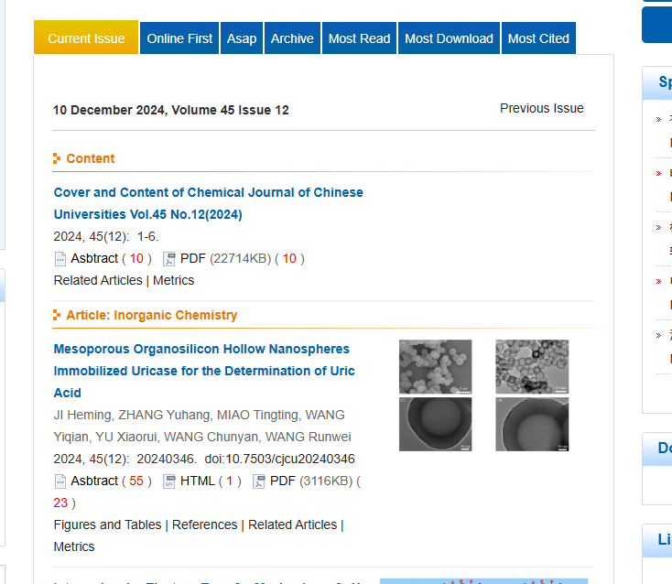

Day

Issue

Page range

Article title

PDF

DOI

**In this DOI is available starting from the 2nd article**